**Task 1:**

#include<iostream>

using namespace std;

int sum(int num)

{

if (num == 0)

{

return num;

}

else return num + sum(num - 1);

}

int main()

{

int x;

int avg;

int num;

cout << "enter number = " << endl;

cin >> num;

cout << "the summation is equal to = ";

cout << sum(num) << endl;

x = sum(num);

avg = x / num;

cout << "avg is equal to = " << avg << endl;

system("pause");

return 0;

}

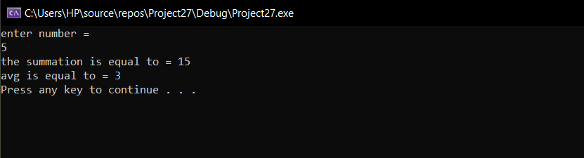

**Task 2:**

#include<iostream>

using namespace std;

int fib(int n)

{

if (n == 0 || n == 1) // base case

{

return n;

}

else // calling function recursively

{

return (fib(n - 1) + fib(n - 2));

}

}

int main() {

int a;

int counter=0;

cout << "enter value please = " << endl;

cin >> a;

while (counter < a)

{

cout << " " << fib(counter) << ",";

counter++;

}

system("pause");

return 0;

}

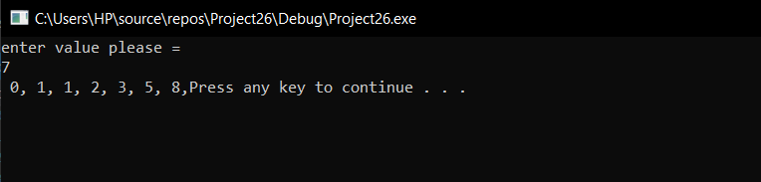

**Task 3:**

#include<iostream>

using namespace std;

int prime(int a, int b) // a will point to number itself, b would be half of that number

{

if (b == 1) // we have to check until b becomes one (dividing)

{

return 1;

}

else if (a % b==0)

return 0;

return (prime(a, b - 1)); // calling recursive fun until base condition is fulfilled

}

int main() {

int p, x;

cout << "enter the number you want to check wheather is a prime no or not ! " << endl;

cin >> p;

int ans;

ans = prime(p, p / 2); // storing the answer provided by function

if (ans == 1)

{

cout << "the number is prime " << endl;

}

else

cout << "the number is not prime " << endl;

system("pause");

return 0;

}

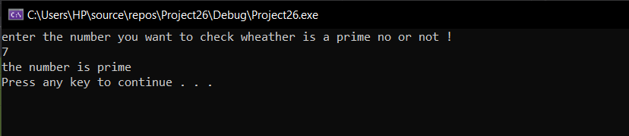

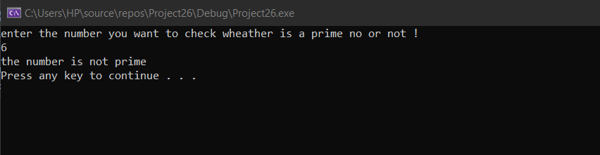

**Task 4:**

#include<iostream>

using namespace std;

int sort(int* p, int size, int i = 0)

{

if (size==i)

{

return 1;

}

else

{

for (int j = 0; j < size; j++)

{

if (p[j] > p[j + 1])

{

swap(p[j], p[j + 1]); // recursive fun calling

}

}

return sort(p, size - 1);

}

}

int main()

{

int size;

cout << "enter size of the array= " << endl;

cin >> size;

int* p = new int[size]; // dma array

cout << "enter elements of the array= " << endl; // input

for (int i = 0; i < size; i++)

{

cin >> *(p+i);

}

sort(p, size-1); // recursive function

cout << "array after buble sorting = " << endl;

for (int i = 0; i < size; i++) // ouput

{

cout << *(p + i) << " ";

}

return 0;

}

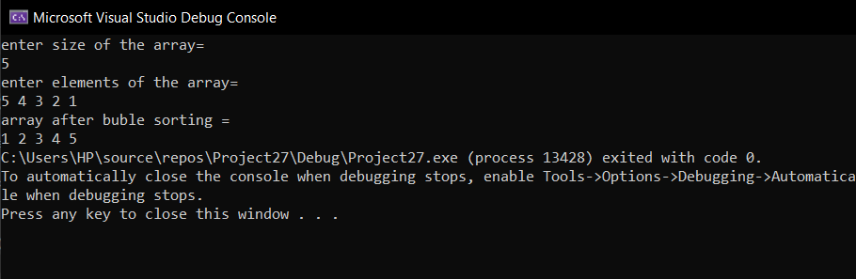

**Task 5:**

#include<iostream>

using namespace std;

struct car

{

char carName[20];

char carModel[20];

int yearModel;

double cost;

}car1;

struct carnumber2

{

char carName[20];

char carModel[20];

int yearModel;

double cost;

}car2;

int main()

{

cout << "enter car1 name = " << endl;

cin >> car1.carName;

cout << "enter car 1 model = " << endl;

cin >> car1.carModel;

cout << "enter cost of car 1 = " << endl;

cin >> car1.cost;

cout << "enter car1 model year = " << endl;

cin >> car1.yearModel;

cout << "enter car2 name = " << endl;

cin >> car2.carName;

cout << "enter car 2 model = " << endl;

cin >> car2.carModel;

cout << "enter cost of car 2 = " << endl;

cin >> car2.cost;

cout << "enter car2 model year = " << endl;

cin >> car2.yearModel;

cout << "------------------OUTPUT------------------" << endl;

cout << "car 1 data = " << endl;

cout << car1.carName << endl;

cout << car1.carModel<<endl;

cout << car1.yearModel << endl;

cout << car1.cost << endl;

cout << "car 2 data = " << endl;

cout << car2.carName << endl;

cout << car2.carModel << endl;

cout << car2.yearModel << endl;

cout << car2.cost << endl;

if (car1.cost > car2.cost)

{

cout << "the car with higher cost is = " << car1.carName<<" "<<car1.carModel;

}

else if (car1.cost < car2.cost)

{

cout << "the car with higher cost is = " << car2.carName<<" "<<car2.carModel;

}

system("pause");

return 0;

}

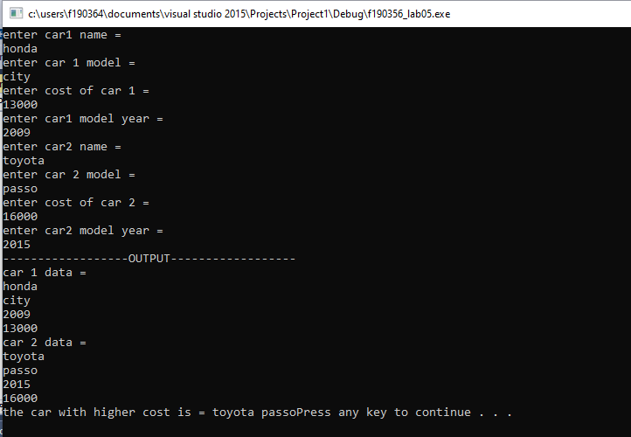

**Task 6**

#include<iostream>

using namespace std;

struct distance

{

float d1[2]; // array for d1

float d2[2]; // array for d2

float d3[2]; // array for d3

}car1; // beacause i used it in previous question , so again using in this one

int main()

{

cout << "enter feets for d1= " << endl;

cin >> car1.d1[0]; // taking in values

cout << "enter inches for d1= " << endl;

cin >> car1.d1[1];

car1.d2[0]=10; // taking in values

car1.d2[1]=5.25;

car1.d3[0] = car1.d1[0] + car1.d2[0];

car1.d3[1] = car1.d1[1] + car1.d2[1];

if (car1.d3[1] >= 12) // after the inches have gone beyond 12 , it would make a feet so i have added the feet into feet section

{

cout << "the inches have been transformed into feets " << endl;

car1.d3[0] = car1.d3[0] + (car1.d3[1] / 12);

float x;

x = floor(car1.d3[0]);

float y;

y=car1.d3[0];

car1.d3[1] = y - x;

car1.d3[0] = x;

cout << "THE ANSWER IS EQUAL TO { " << car1.d3[0] << "," << (car1.d3[1] ) << "}" << endl;

}

else if (car1.d3[1] < 12) // simply add and display if inches are not greater than 12

{

cout << "THE ANSWER IS EQUAL TO { " << car1.d3[0] << "," << (car1.d3[1]) << "}" << endl;

}

system("pause");

return 0;

}

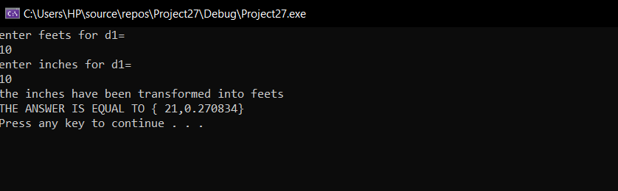

**Task 7:**

#include<iostream>

using namespace std;

// i have made this program in a long way (i wanted to understand the program from a basic level so after understanding this i will

// move on doing it by func and loops more often

struct drink1

{

string drinkname;

float drinkcost;

int no_of_drinks;

}d1; // i have used d1 as structure variable

int main()

{

int x; // for loop

float total_money = 0;

int size = 4;

drink1* p = new drink1[size]; // dma array for structures

float money;

cout << "HOW MANY TIMES YOU WANT TO USE A VENDING MACHINE ? = " << endl;

cin >> x;

// this would allow user to add his desired drinks,costs and quantity

for (int i = 0;i < 4;i++)

{

cout << "enter drink number " << i + 1 << " ! " << endl;

cin >> p[i].drinkname;

cout << "enter drink number " << i + 1 << "'s cost = " << endl;

cin >> p[i].drinkcost;

cout << "enter drink number " << i + 1 << "'s quantity = " << endl;

cin >> p[i].no_of_drinks;

}

// displaying the vending machines options

for (int i = 0;i < x;i++) // would run as much as user has entered in variable x above

{

cout << endl;

cout << "LIST OF DRINKS = " << endl;

{

cout << "1. " << p[0].drinkname << endl;

cout << "2. " << p[1].drinkname << endl;

cout << "3. " << p[2].drinkname << endl;

cout << "4. " << p[3].drinkname << endl;

cout << endl;

int choice;

cout << "enter 0 if you want to exist and 1,2,3,4 integerw for selecting a drink" << endl;

cin >> choice; // havent used switch beacuse i wanted to understand the program from every line

if (choice == 0)

{

return 0;

}

else if (choice != 0)

{

if (choice == 1)

{

// covering all the requirements for drink 1

if (p[0].no_of_drinks == 0)

{

cout << "sorry but drink has been sold out" << endl;

}

else

{

cout << "you have choosen = " << p[0].drinkname << endl;

cout << "enter how much money you want to enter = " << endl;

cin >> money;

if (money > 0 && money < 1 && money<p[0].drinkcost)

{

cout << "the change that would be given back to you will be = " << (money = p[0].drinkcost-money) << endl;

p[0].no_of_drinks = p[0].no_of_drinks - 1;

(total_money = total_money + p[0].drinkcost);

}

// limitations expressed in mannual

else cout << "money has exceeded normal limit or you cant enter less than cost" << endl;

}

}

else if (choice == 2)

{

// covering all the requirements for drink 2

if (p[1].no_of_drinks == 0)

{

cout << "sorry but drink has been sold out" << endl;

}

else

{

cout << "you have choosen = " << p[1].drinkname << endl;

float money;

cout << "enter how much money you want to enter = " << endl;

cin >> money;

if (money > 0 && money < 1 && money < p[1].drinkcost)

{

cout << "the change that would be given back to you will be = " << (money = p[1].drinkcost - money) << endl;

p[1].no_of_drinks = p[1].no_of_drinks - 1;

(total_money = total_money + p[1].drinkcost);

}

else cout << "error exceeded limit or you cant enter less than cost" << endl;

}

}

else if (choice == 3)

{

// covering all the requirements for drink 3

if (p[2].no_of_drinks == 0)

{

cout << "sorry but drink has been sold out" << endl;

}

else {

cout << "you have choosen = " << p[2].drinkname << endl;

float money;

cout << "enter how much money you want to enter = " << endl;

cin >> money;

if (money > 0 && money < 1 && money < p[2].drinkcost)

{

cout << "the change that would be given back to you will be = " << (money = p[2].drinkcost - money) << endl;

p[2].no_of_drinks = p[2].no_of_drinks - 1;

(total_money = total_money + p[2].drinkcost);

}

else cout << "error exceeded normal limit and you cant enter money less than cost " << endl;

}

}

else if (choice == 4)

{

// covering all the requirements for drink 4

if (p[3].no_of_drinks == 0)

{

cout << "sorry but drink has been sold out" << endl;

}

else {

cout << "you have choosen = " << p[3].drinkname << endl;

float money;

cout << "enter how much money you want to enter = " << endl;

cin >> money;

if (money > 0 && money < 1 && money < p[3].drinkcost)

{

cout << "the change that would be given back to you will be = " << (money = p[3].drinkcost - money) << endl;

p[3].no_of_drinks = p[3].no_of_drinks - 1;

(total_money = total_money + p[3].drinkcost);

}

else cout << "error exceeded normal limit and you cant enter money less than cost " << endl;

}

}

else

cout << "invalid choice ! " << endl;

}

}

}

// displaying the money made by the machine in the end

cout << "total money made by machine is = " << total_money << endl;

system("pause");

return 0;

}

